Exp. No: 8
Implementation of Dielectric Free-Space Boundary Conditions in Electric Field and Determination of Relative Permittivity
Test Case (i) – Normal and Tangential Field Components at the Free-Space / Dielectric Interface
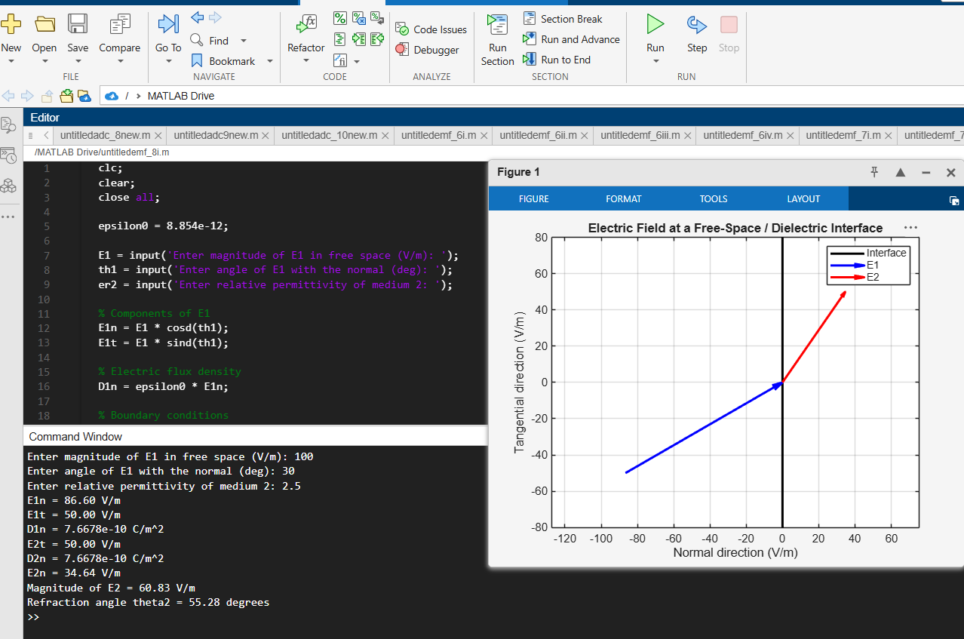
Test Case (ii) – Determination of the Unknown Relative Permittivity from Boundary-Field Data
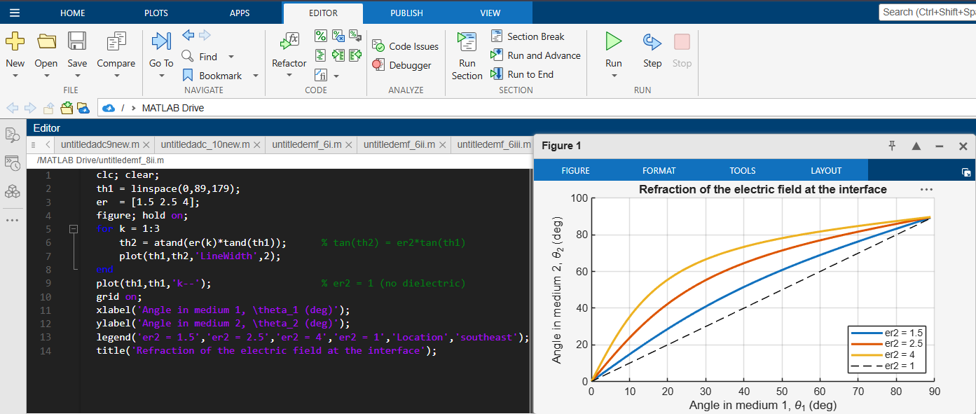
Test Case (iii) – Variation of the Refraction Angle with the Angle of Incidence for Different Dielectrics
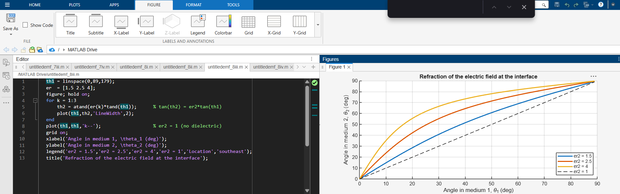
Test Case (iv) – Effect of the Relative Permittivity on the Field Components in the Dielectric
